Title: Waste Detection by using YOLOv8
Done by : Pritesh Ram Keshri Project Number : 05, Submission Date: 16th June 2025
Overview:

This project presents an intelligent waste segregation system that utilizes the YOLOv8 object detection model to identify and classify waste items captured via a live webcam stream. The waste items are categorized into recyclable, non-recyclable, and hazardous types. The model was trained using a curated dataset and deployed through a Streamlit application for real-time monitoring and detection.
Libraries used:

- Ultralytics YOLOv8 – For object detection and model training
- OpenCV (cv2) – Video frame capture and manipulation
- Streamlit – Web interface for real-time detection
- NumPy – Array operations
- Matplotlib – Visualization of results
- Pandas – Dataframe support (if needed during analysis)

Dataset Details:

- Source: Roboflow Waste Detection Dataset
- Format: Labeled dataset for YOLO object detection
- Classes:
- Recyclable: cardboard_box, can, plastic_bottle_cap, plastic_bottle, reusable_paper
- Non-Recyclable: plastic_bag, scrap_paper, stick, plastic_cup, snack_bag, plastic_box, straw, plastic_cup_lid, scrap_plastic, cardboard_bowl, plastic_cutlery
- Hazardous: battery, chemical_spray_can, chemical_plastic_bottle, chemical_plastic_gallon, light_bulb, paint_bucket

APIs Integrated:

No external APIs integrated. Application is deployed directly using Streamlit.
Source code 1: File Name : Clone & Run Setup (setup.sh)

git clone https://github.com/boss4848/waste-detection.git
cd waste-detection
pip install -r requirements.txt
streamlit run app.py
Source code 2: File name: Streamlit App (app.py)

import streamlit as st
from ultralytics import YOLO
import cv2

model = YOLO("best.pt")

st.title("Intelligent Waste Detection")
frame = st.camera_input("Capture a Frame")

if frame:
img = cv2.imdecode(np.frombuffer(frame.read(), np.uint8), 1)
results = model(img)
annotated_img = results[0].plot()
st.image(annotated_img, caption="Detection Output")

Source code 3: Helper Functions (helper.py)

def load_model(model_path="best.pt"):
from ultralytics import YOLO
return YOLO(model_path)

def predict_and_draw(model, frame):
results = model(frame)
return results[0].plot()
Source Code 4: Model Training (train.py)

yolo task=detect mode=train model=yolov8n.pt data=your_dataset.yaml epochs=50 imgsz=640
Output screenshots:

1. Streamlit Web Interface: Below image shows the streamlit web interface of the waste
Detection .

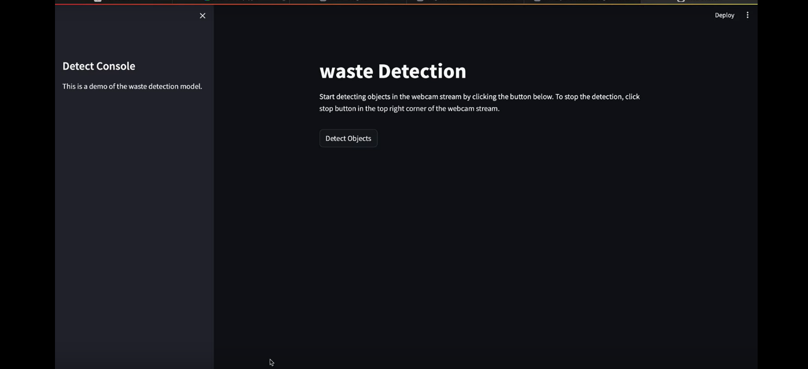

2. Prediction Samples: Here’s how you can see the prediction sample of the waste classification using YOLOv8.
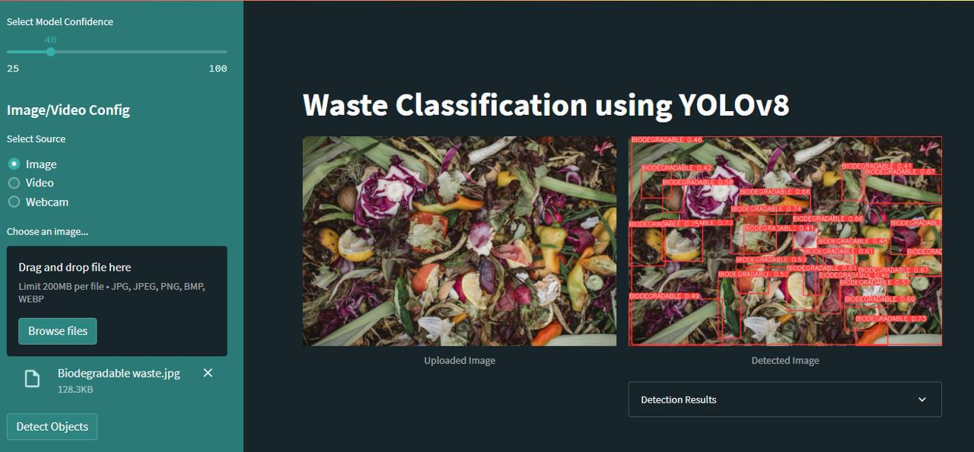

3. Real-Time Detection: Given two images shows the real-time detection of the waste which also classifies the hazardous items.

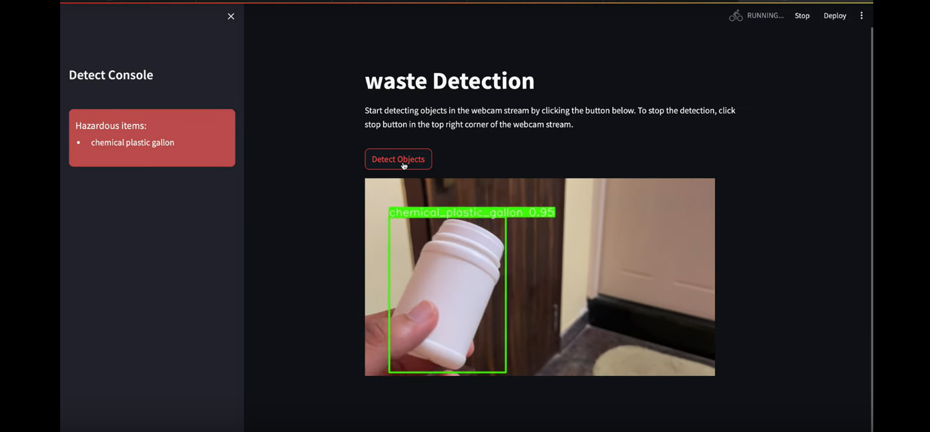

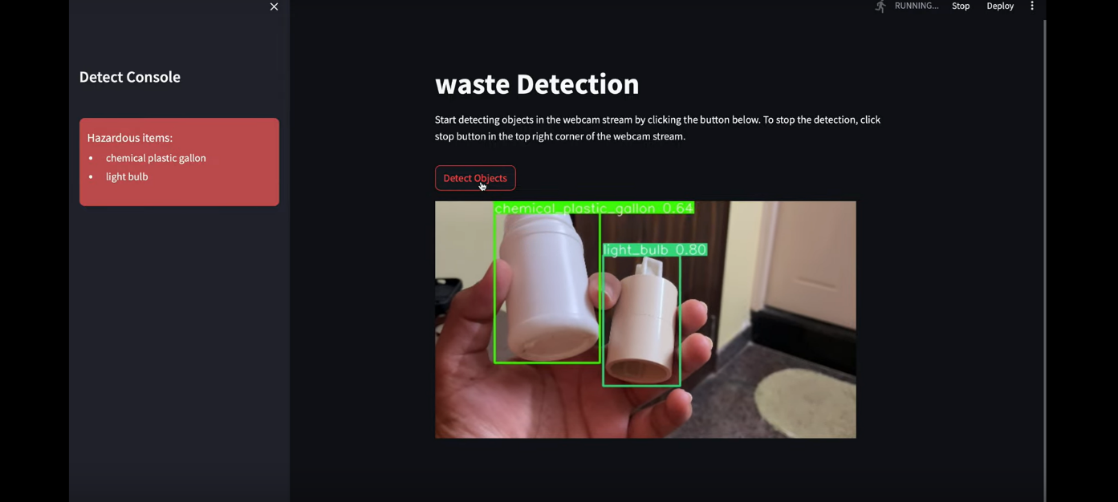

What you learned:

Through this project, I gained practical knowledge of:
- Object detection with YOLOv8
- Real-time video processing using OpenCV
- Designing and deploying applications with Streamlit
- Understanding class imbalance and annotation techniques
- Model training, validation, and testing using custom datasets
What the Skills you gained:

- Built real-time computer vision applications
- Trained object detection models using YOLO
- Handled labeled datasets and YOLO formatting
- Web deployment using Streamlit
- Visualized and interpreted model predictions

Real Time Applications:

- Smart Dustbins: Automated waste sorting systems
- Urban Sanitation Monitoring: Detect improper waste disposal
- Recycling Plants: Categorize incoming waste streams
- Public Surveillance: Identify hazardous material disposal
- Educational Tools: Promote waste awareness through demos

Further Enhancement Suggestions:

- Integrate robotic arm controls for automated sorting
- Include voice alerts or LED indicators
- Deploy on edge devices like Raspberry Pi
- Implement cloud-based dashboards for municipal monitoring
- Add feedback system for missed/wrong detections
- Train with larger and diversified datasets

Training Performance (Example):
Epoch | Training mAP50 | Validation mAP50 | Loss
1 | 42.1% | 40.8% | 0.72
10 | 81.6% | 78.9% | 0.25
50 | 92.3% | 91.0% | 0.09

